Prueba de Pearson y Granger.

Eviews:

**PEARSON -CORRELATION**

|  | RI | VAB |
| --- | --- | --- |
| RI | 1.000000 | 0.964878 |
| VAB | 0.964878 | 1.000000 |

Para verificar la presencia de correlación entre estas dos variables se realizó la prueba de Pearson, en la cual se obtuvo una significancia de 0.000, lo cual nos indica que la relación entre estas dos variables es estadísticamente significativa.

GRANGER

| Pairwise Granger Causality Tests | | | |
| --- | --- | --- | --- |
| Date: 12/25/21 Time: 16:30 | | | |
| Sample: 2007 2019 | | |  |
| Lags: 1 | |  |  |
|  |  |  |  |
|  |  |  |  |
| Null Hypothesis: | Obs | F-Statistic | Prob. |
|  |  |  |  |
|  |  |  |  |
| RI does not Granger Cause VAB | 12 | 0.58638 | 0.4634 |
| VAB does not Granger Cause RI | | 8.32354 | 0.0180 |
|  |  |  |  |
|  |  |  |  |

Se llevó a cabo un análisis de causalidad para las combinaciones de ambos pares de variables,entre la recaudación de impuestos y el Valor Agregado Bruto. El test de causalidad de Granger,nos da como resultado un p-valor<0.05, por lo cual rechazamos la hipótesis nula de que VAB no causa RI. Para el cálculo del rezago óptimo se tuvo el apoyo del criterio de información de Akaike en el cual se obtuvo que el primer rezago era el óptimo.

Excel:

Recaudación de impuestos a VAB

No restrictiva

| PBI Dep | PBI_1 | Ri_1 |
| --- | --- | --- |
| 2.975.676 | 0 | 0 |
| 3.401.175 | 2.975.676 | 25.020,4 |
| 3.750.401 | 3.401.175 | 29.113,7 |
| 3.922.514 | 3.750.401 | 32.839,0 |
| 4.111.349 | 3.922.514 | 37.742,9 |
| 4.482.971 | 4.111.349 | 41.722,8 |
| 4.906.299 | 4.482.971 | 64.001,3 |
| 4.879.476 | 4.906.299 | 80.722,3 |
| 5.162.331 | 4.879.476 | 106.162,8 |
| 5.177.917 | 5.162.331 | 114.587,5 |
| 5.451.854 | 5.177.917 | 122.901,2 |
| 5.759.773 | 5.451.854 | 122.129,7 |
| 5.925.434 | 5.759.773 | 137.160,7 |

* Restrictiva

| PBI Dep | PBI_1 |
| --- | --- |
| 2.975.676 |  |
| 3.401.175 | 2.975.676 |
| 3.750.401 | 3.401.175 |
| 3.922.514 | 3.750.401 |
| 4.111.349 | 3.922.514 |
| 4.482.971 | 4.111.349 |
| 4.906.299 | 4.482.971 |
| 4.879.476 | 4.906.299 |
| 5.162.331 | 4.879.476 |
| 5.177.917 | 5.162.331 |
| 5.451.854 | 5.177.917 |
| 5.759.773 | 5.451.854 |
| 5.925.434 | 5.759.773 |

Regresiones:

* No restrictiva

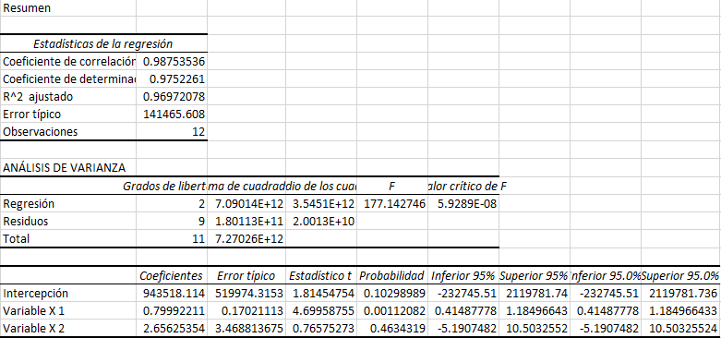

* Restrictiva

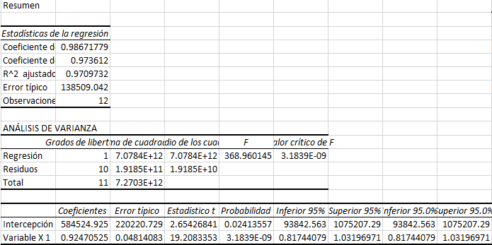

* Dado que nuestra F_calculada en menor a nuestra F tabla, No se rechaza la H0, por ende el Ri no Causa a PBI .

VAB a Recaudación de impuestos

* No restrictiva

| Ri | Ri | VAB_1 |
| --- | --- | --- |
| 25.020,4 |  |  |
| 29.113,7 | 25.020 | 2.975.676,0 |
| 32.839,0 | 29.114 | 3.401.175,0 |
| 37.742,9 | 32.839 | 3.750.401,0 |
| 41.722,8 | 37.743 | 3.922.514,0 |
| 64.001,3 | 41.723 | 4.111.349,0 |
| 80.722,3 | 64.001 | 4.482.971,0 |
| 106.162,8 | 80.722 | 4.906.299,0 |
| 114.587,5 | 106.163 | 4.879.476,0 |
| 122.901,2 | 114.588 | 5.162.331,0 |
| 122.129,7 | 122.901 | 5.177.917,0 |
| 137.160,7 | 122.130 | 5.451.854,0 |
| 143.378,5 | 137.161 | 5.759.773,0 |

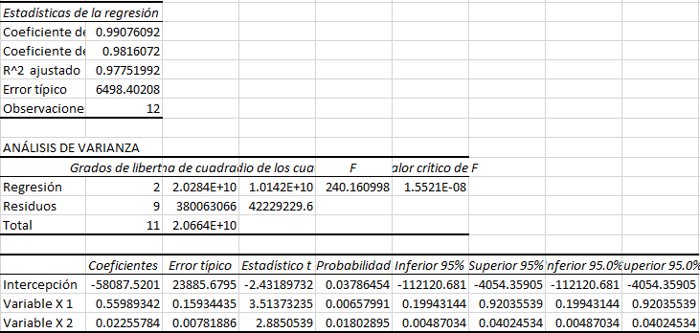

* Restrictiva

| Ri | Ri_1 |
| --- | --- |
| 25.020,4 |  |
| 29.113,7 | 25.020 |
| 32.839,0 | 29.114 |
| 37.742,9 | 32.839 |
| 41.722,8 | 37.743 |
| 64.001,3 | 41.723 |
| 80.722,3 | 64.001 |
| 106.162,8 | 80.722 |
| 114.587,5 | 106.163 |
| 122.901,2 | 114.588 |
| 122.129,7 | 122.901 |
| 137.160,7 | 122.130 |
| 143.378,5 | 137.161 |

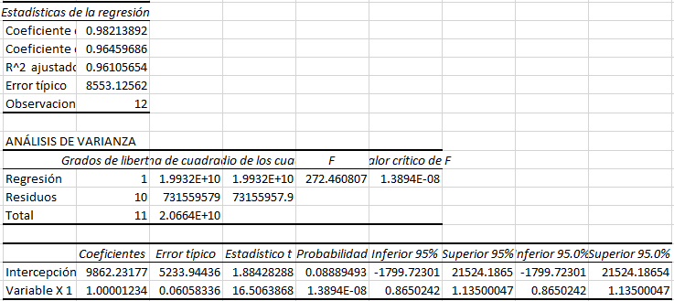

* Dado que nuestra F Calculada es mayor a nuestra F tabla, rechazamos la H0, por ende el VAB Causa a Ri.

Stata:

**Prueba de Dickey Fuller.**

Eviews:

**Prueba de Dickey Fuller VAB**

| Null Hypothesis: LOGVAB has a unit root | | | |  |
| --- | --- | --- | --- | --- |
| Exogenous: Constant | | |  |  |
| Lag Length: 1 (Fixed) | | |  |  |
|  |  |  |  |  |
|  |  |  |  |  |
|  |  |  | t-Statistic | Prob.* |
|  |  |  |  |  |
|  |  |  |  |  |
| Augmented Dickey-Fuller test statistic | | | -1.905883 | 0.3179 |
| Test critical values: | 1% level |  | -4.200056 |  |
|  | 5% level |  | -3.175352 |  |
|  | 10% level |  | -2.728985 |  |
|  |  |  |  |  |
|  |  |  |  |  |
| *MacKinnon (1996) one-sided p-values. | | | |  |
| Warning: Probabilities and critical values calculated for 20 observations | | | | |
| and may not be accurate for a sample size of 11 | | | | |
|  |  |  |  |  |
|  |  |  |  |  |
| Augmented Dickey-Fuller Test Equation | | | |  |
| Dependent Variable: D(LOGVAB) | | |  |  |
| Method: Least Squares | | |  |  |
| Date: 12/27/21 Time: 21:05 | | |  |  |
| Sample (adjusted): 3 13 | | |  |  |
| Included observations: 11 after adjustments | | | |  |
|  |  |  |  |  |
|  |  |  |  |  |
| Variable | Coefficient | Std. Error | t-Statistic | Prob. |
|  |  |  |  |  |
|  |  |  |  |  |
| LOGVAB(-1) | -0.131322 | 0.068904 | -1.905883 | 0.0931 |
| D(LOGVAB(-1)) | -0.183261 | 0.286603 | -0.639425 | 0.5404 |
| C | 2.075542 | 1.066526 | 1.946078 | 0.0875 |
|  |  |  |  |  |
|  |  |  |  |  |
| R-squared | 0.327569 | Mean dependent var | | 0.050467 |
| Adjusted R-squared | 0.159461 | S.D. dependent var | | 0.033297 |
| S.E. of regression | 0.030527 | Akaike info criterion | | -3.913386 |
| Sum squared resid | 0.007455 | Schwarz criterion | | -3.804869 |
| Log likelihood | 24.52362 | Hannan-Quinn criter. | | -3.981791 |
| F-statistic | 1.948563 | Durbin-Watson stat | | 2.288488 |
| Prob(F-statistic) | 0.204452 |  |  |  |
|  |  |  |  |  |
|  |  |  |  |  |

Para este análisis se aplicó el test de estacionariedad más empleado en la literatura, el test de Dickey-Fuller aumentado, en el cual se utilizó la serie de logaritmo de la variable VAB con su diferencia,cada prueba se realizó con el apoyo del criterio de información de Akaike. Como resultado se obtuvo un valor crítico de -1.91 el cual es menor que -2.86,tomando un valor de significancia de 5%, por tanto se acepta la hipótesis nula, en el cual se acepta la existencia de raíz unitaria y la no estacionariedad.(ESTACIONARIEDAD?).

| Valores críticos asintóticos para la prueba t de raíz unitaria: sin tendencia de tiempo | | | | |
| --- | --- | --- | --- | --- |
| Nivel de sig. | 1% | 2.5% | 5% | 10% |
| Valor crítico | -3.43 | -3.12 | -2.86 | -2.57 |

| Null Hypothesis: RI has a unit root | | | |  |
| --- | --- | --- | --- | --- |
| Exogenous: Constant | | |  |  |
| Bandwidth: 1 (Used-specified) using Bartlett kernel | | | | |
|  |  |  |  |  |
|  |  |  |  |  |
|  |  |  | Adj. t-Stat | Prob.* |
|  |  |  |  |  |
|  |  |  |  |  |
| Phillips-Perron test statistic | | | -0.056635 | 0.9339 |
| Test critical values: | 1% level |  | -4.121990 |  |
|  | 5% level |  | -3.144920 |  |
|  | 10% level |  | -2.713751 |  |
|  |  |  |  |  |
|  |  |  |  |  |
| *MacKinnon (1996) one-sided p-values. | | | |  |
| Warning: Probabilities and critical values calculated for 20 observations | | | | |
| and may not be accurate for a sample size of 12 | | | | |
|  |  |  |  |  |
|  |  |  |  |  |
|  |  |  |  |  |
| Residual variance (no correction) | | | | 60963298 |
| HAC corrected variance (Bartlett kernel) | | | | 72334618 |
|  |  |  |  |  |
|  |  |  |  |  |
|  |  |  |  |  |
|  |  |  |  |  |
| Phillips-Perron Test Equation | | |  |  |
| Dependent Variable: D(RI) | | |  |  |
| Method: Least Squares | | |  |  |
| Date: 12/27/21 Time: 21:40 | | |  |  |
| Sample (adjusted): 2 13 | | |  |  |
| Included observations: 12 after adjustments | | | |  |
|  |  |  |  |  |
|  |  |  |  |  |
| Variable | Coefficient | Std. Error | t-Statistic | Prob. |
|  |  |  |  |  |
|  |  |  |  |  |
| RI(-1) | 1.23E-05 | 0.060583 | 0.000204 | 0.9998 |
| C | 9862.232 | 5233.944 | 1.884283 | 0.0889 |
|  |  |  |  |  |
|  |  |  |  |  |
| R-squared | 0.000000 | Mean dependent var | | 9863.172 |
| Adjusted R-squared | -0.100000 | S.D. dependent var | | 8155.085 |
| S.E. of regression | 8553.126 | Akaike info criterion | | 21.09699 |
| Sum squared resid | 7.32E+08 | Schwarz criterion | | 21.17781 |
| Log likelihood | -124.5820 | Hannan-Quinn criter. | | 21.06707 |
| F-statistic | 4.15E-08 | Durbin-Watson stat | | 1.563275 |
| Prob(F-statistic) | 0.999842 |  |  |  |
|  |  |  |  |  |

Para este análisis se aplicó el test de estacionariedad más empleado en la literatura, el test de Dickey-Fuller aumentado, en el cual se utilizó la serie de logaritmo de la variable RI con su diferencia,cada prueba se realizó con el apoyo del criterio de información de Akaike. Como resultado se obtuvo un valor crítico de -0.057 el cual es menor que -2.86,tomando un valor de significancia de 5%, por tanto se acepta la hipótesis nula, en el cual se acepta la existencia de raíz unitaria y la no estacionalidad.

| Valores críticos asintóticos para la prueba t de raíz unitaria: sin tendencia de tiempo | | | | |
| --- | --- | --- | --- | --- |
| Nivel de sig. | 1% | 2.5% | 5% | 10% |
| Valor crítico | -3.43 | -3.12 | -2.86 | -2.57 |

Excel:

| Año | dlnVAB | lnVBA_1 | dlnVAB_1 |
| --- | --- | --- | --- |
| 2007 |  |  |  |
| 2008 | 0,1336497201 | 14,9059818 |  |
| 2009 | 0,09774180744 | 15,03963152 | 0,1336497201 |
| 2010 | 0,04487000717 | 15,13737333 | 0,09774180744 |
| 2011 | 0,04701842373 | 15,18224333 | 0,04487000717 |
| 2012 | 0,08653479777 | 15,22926176 | 0,04701842373 |
| 2013 | 0,09023389349 | 15,31579655 | 0,08653479777 |
| 2014 | -0,005482052709 | 15,40603045 | 0,09023389349 |
| 2015 | 0,05635038462 | 15,4005484 | -0,005482052709 |
| 2016 | 0,003014630172 | 15,45689878 | 0,05635038462 |
| 2017 | 0,05155288247 | 15,45991341 | 0,003014630172 |
| 2018 | 0,0549423299 | 15,51146629 | 0,05155288247 |
| 2019 | 0,02835586907 | 15,56640862 | 0,0549423299 |

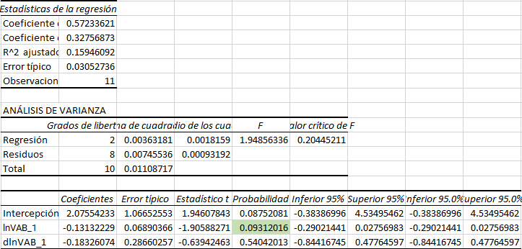

Stata:

evaluando el dickey fuller

Ho: RAIZ UNITARIA(No es estacionalidad)

H1: NO EXISTE RAIZ UNITARIA(es estacionalidad)

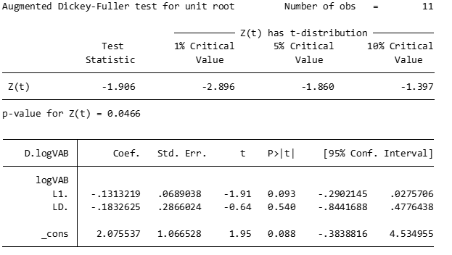

Durbin-Watson d-statistic( 4, 11) = 2.058319

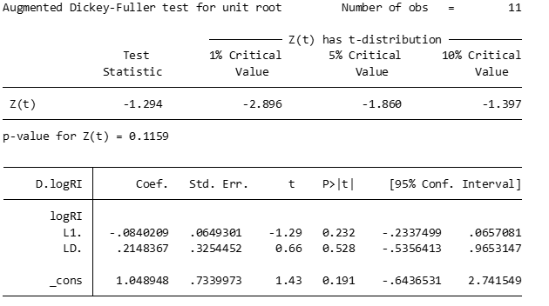

Durbin-Watson d-statistic( 4, 11) = 2.058319

**Prueba de Phillips Perron.**

Eviews:

| Null Hypothesis: VAB has a unit root | | | |  |
| --- | --- | --- | --- | --- |
| Exogenous: Constant | | |  |  |
| Bandwidth: 1 (Used-specified) using Bartlett kernel | | | | |
|  |  |  |  |  |
|  |  |  |  |  |
|  |  |  | Adj. t-Stat | Prob.* |
|  |  |  |  |  |
|  |  |  |  |  |
| Phillips-Perron test statistic | | | -1.753147 | 0.3829 |
| Test critical values: | 1% level |  | -4.121990 |  |
|  | 5% level |  | -3.144920 |  |
|  | 10% level |  | -2.713751 |  |
|  |  |  |  |  |
|  |  |  |  |  |
| *MacKinnon (1996) one-sided p-values. | | | |  |
| Warning: Probabilities and critical values calculated for 20 observations | | | | |
| and may not be accurate for a sample size of 12 | | | | |
|  |  |  |  |  |
|  |  |  |  |  |
|  |  |  |  |  |
| Residual variance (no correction) | | | | 1.60E+10 |
| HAC corrected variance (Bartlett kernel) | | | | 1.16E+10 |
|  |  |  |  |  |
|  |  |  |  |  |
|  |  |  |  |  |
|  |  |  |  |  |
| Phillips-Perron Test Equation | | |  |  |
| Dependent Variable: D(VAB) | | |  |  |
| Method: Least Squares | | |  |  |
| Date: 12/27/21 Time: 21:46 | | |  |  |
| Sample (adjusted): 2 13 | | |  |  |
| Included observations: 12 after adjustments | | | |  |
|  |  |  |  |  |
|  |  |  |  |  |
| Variable | Coefficient | Std. Error | t-Statistic | Prob. |
|  |  |  |  |  |
|  |  |  |  |  |
| VAB(-1) | -0.075295 | 0.048141 | -1.564052 | 0.1489 |
| C | 584524.9 | 220220.7 | 2.654268 | 0.0241 |
|  |  |  |  |  |
|  |  |  |  |  |
| R-squared | 0.196546 | Mean dependent var | | 245813.2 |
| Adjusted R-squared | 0.116200 | S.D. dependent var | | 147333.4 |
| S.E. of regression | 138509.0 | Akaike info criterion | | 26.66627 |
| Sum squared resid | 1.92E+11 | Schwarz criterion | | 26.74709 |
| Log likelihood | -157.9976 | Hannan-Quinn criter. | | 26.63635 |
| F-statistic | 2.446257 | Durbin-Watson stat | | 2.529975 |
| Prob(F-statistic) | 0.148872 |  |  |  |
|  |  |  |  |  |
|  |  |  |  |  |

Se acepta H0:La variable contiene raíz unitaria, NO ES ESTACIONARIO.

| Null Hypothesis: ri has a unit root | | | |  |
| --- | --- | --- | --- | --- |
| Exogenous: Constant | | |  |  |
| Bandwidth: 1 (Used-specified) using Bartlett kernel | | | | |
|  |  |  |  |  |
|  |  |  |  |  |
|  |  |  | Adj. t-Stat | Prob.* |
|  |  |  |  |  |
|  |  |  |  |  |
| Phillips-Perron test statistic | | | -0.056635 | 0.9339 |
| Test critical values: | 1% level |  | -4.121990 |  |
|  | 5% level |  | -3.144920 |  |
|  | 10% level |  | -2.713751 |  |
|  |  |  |  |  |
|  |  |  |  |  |
| *MacKinnon (1996) one-sided p-values. | | | |  |
| Warning: Probabilities and critical values calculated for 20 observations | | | | |
| and may not be accurate for a sample size of 12 | | | | |
|  |  |  |  |  |
|  |  |  |  |  |
|  |  |  |  |  |
| Residual variance (no correction) | | | | 60963298 |
| HAC corrected variance (Bartlett kernel) | | | | 72334618 |
|  |  |  |  |  |
|  |  |  |  |  |
|  |  |  |  |  |
|  |  |  |  |  |
| Phillips-Perron Test Equation | | |  |  |
| Dependent Variable: D(RI) | | |  |  |
| Method: Least Squares | | |  |  |
| Date: 12/27/21 Time: 21:40 | | |  |  |
| Sample (adjusted): 2 13 | | |  |  |
| Included observations: 12 after adjustments | | | |  |
|  |  |  |  |  |
|  |  |  |  |  |
| Variable | Coefficient | Std. Error | t-Statistic | Prob. |
|  |  |  |  |  |
|  |  |  |  |  |
| RI(-1) | 1.23E-05 | 0.060583 | 0.000204 | 0.9998 |
| C | 9862.232 | 5233.944 | 1.884283 | 0.0889 |
|  |  |  |  |  |
|  |  |  |  |  |
| R-squared | 0.000000 | Mean dependent var | | 9863.172 |
| Adjusted R-squared | -0.100000 | S.D. dependent var | | 8155.085 |
| S.E. of regression | 8553.126 | Akaike info criterion | | 21.09699 |
| Sum squared resid | 7.32E+08 | Schwarz criterion | | 21.17781 |
| Log likelihood | -124.5820 | Hannan-Quinn criter. | | 21.06707 |
| F-statistic | 4.15E-08 | Durbin-Watson stat | | 1.563275 |
| Prob(F-statistic) | 0.999842 |  |  |  |
|  |  |  |  |  |

Excel:

| Año | Ri | Ri_1 |
| --- | --- | --- |
| 2007 | 25.020,4 | 0 |
| 2008 | 29.113,7 | 25.020,4 |
| 2009 | 32.839,0 | 29.113,7 |
| 2010 | 37.742,9 | 32.839,0 |
| 2011 | 41.722,8 | 37.742,9 |
| 2012 | 64.001,3 | 41.722,8 |
| 2013 | 80.722,3 | 64.001,3 |
| 2014 | 106.162,8 | 80.722,3 |
| 2015 | 114.587,5 | 106.162,8 |
| 2016 | 122.901,2 | 114.587,5 |
| 2017 | 122.129,7 | 122.901,2 |
| 2018 | 137.160,7 | 122.129,7 |

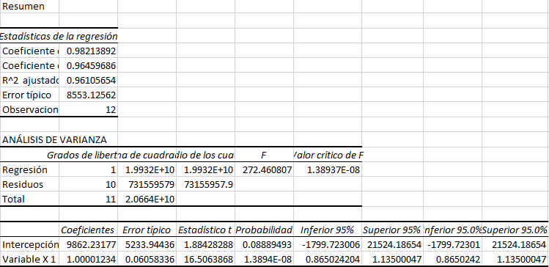

| Año | VAB | VAB_1 |
| --- | --- | --- |
| 2007 | 2.975.676 |  |
| 2008 | 3.401.175 | 2.975.676 |
| 2009 | 3.750.401 | 3.401.175 |
| 2010 | 3.922.514 | 3.750.401 |
| 2011 | 4.111.349 | 3.922.514 |
| 2012 | 4.482.971 | 4.111.349 |
| 2013 | 4.906.299 | 4.482.971 |
| 2014 | 4.879.476 | 4.906.299 |
| 2015 | 5.162.331 | 4.879.476 |
| 2016 | 5.177.917 | 5.162.331 |
| 2017 | 5.451.854 | 5.177.917 |
| 2018 | 5.759.773 | 5.451.854 |
| 2019 | 5.925.434 | 5.759.773 |

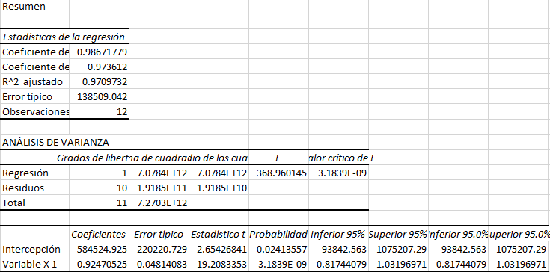

Stata:

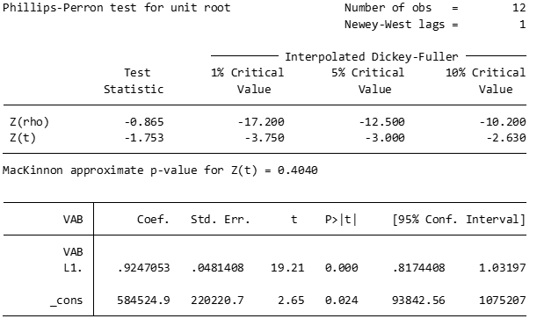

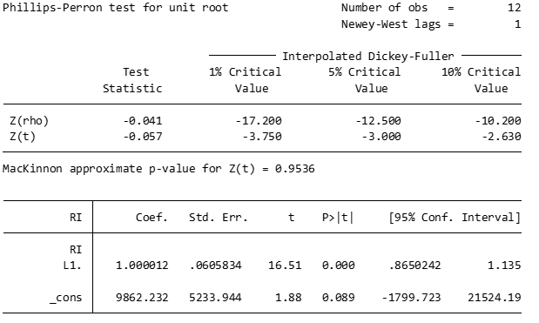

PARAMÉTRICA(Aquí se usa PEARSON)

<https://www.youtube.com/watch?v=1QFf5luX3kA>

<https://www.youtube.com/watch?v=YiOHjyji4_Y>

Intervalo o razón

Muestra grande

Muestreo aleatotio

No PARAMÉTRICA

Nominal u Ordinal

Muestra pequeña